Auto scaling Group Project (Using Default VPC)
TF-AutoScalingGroup-Complete-Procedure/
│
├── modules/
│ │
│ ├── alb/
│ │ ├── main.tf # ALB, Target Group, Listener
│ │ ├── security.tf # Security Groups (ALB & EC2)
│ │ ├── variables.tf # vpc_id, subnet_ids, my_ip
│ │ └── outputs.tf # alb_dns_name, target_group_arn, ec2_sg_id
│ │
│ ├── autoscaling/
│ │ ├── main.tf # Launch Template, ASG, Scaling Policies
│ │ ├── cloudwatch.tf # CPU High / Low alarms
│ │ ├── variables.tf # AMI, instance type, ASG sizes, SNS ARN
│ │ └── outputs.tf # asg_name
│ │
│ └── s3/
│ ├── main.tf # S3 bucket + ALB access log policy
│ ├── variables.tf # bucket_name
│ └── outputs.tf # bucket_name, bucket_arn
│
├── provider.tf # AWS provider & region
├── variables.tf # Global variables
├── terraform.tfvars # Environment values
├── data.tf # Default VPC, subnets, AMI, caller identity
├── main.tf # Root module wiring (ALB, ASG, S3)
├── outputs.tf # Final ALB DNS output
│
├── sns.tf # SNS topic + email subscription
├── keypair.tf # EC2 key pair
├── user_data.sh # Apache + website install script
├── asgkey.pub # Public SSH key
👉 Uses AWS Default VPC + Subnets

1️⃣ provider.tf
terraform {
required_providers {
aws = {
source = "hashicorp/aws"
version = "~> 5.0"
}
}
}

provider "aws" {
region = var.region
}

2️⃣ variables.tf (Root)
variable "region" {
type = string
}

variable "instance_type" {
type = string
}

variable "asg_min" {
type = number
}

variable "asg_max" {
type = number
}

variable "asg_desired" {
type = number
}

variable "my_ip" {
type = string
}
variable "log_bucket_time" {
type = string
}

3️⃣ terraform.tfvars
region = "us-east-1"
instance_type = "t2.micro"

asg_min = 1
asg_max = 3
asg_desired = 2

my_ip = "87.154.160.239/32"

log_bucket_time = "23012026-1940"

4️⃣ data.tf (Default VPC + Subnets + AMI)
data "aws_vpc" "default" {
default = true
}

data "aws_subnets" "default" {
filter {
name = "vpc-id"
values = [data.aws_vpc.default.id]
}
}

data "aws_ami" "amazon_linux" {
most_recent = true
owners = ["amazon"]

filter {
name = "name"
values = ["amzn2-ami-hvm-*-x86_64-gp2"]
}
}

5️⃣ main.tf (Call Modules)
module "alb" {
source = "./modules/alb"
vpc_id = data.aws_vpc.default.id
subnet_ids = data.aws_subnets.default.ids
my_ip = var.my_ip

log_bucket_name = module.s3.bucket_name
}

module "autoscaling" {
source = "./modules/autoscaling"

ami_id = data.aws_ami.amazon_linux.id
instance_type = var.instance_type
subnet_ids = data.aws_subnets.default.ids
key_name = aws_key_pair.asg_key.key_name
ec2_sg_id = module.alb.ec2_sg_id
target_group_arn = module.alb.target_group_arn

asg_min = var.asg_min
asg_max = var.asg_max
asg_desired = var.asg_desired
user_data = base64encode(file("user_data.sh"))
sns_topic_arn = aws_sns_topic.my_sns_topic.arn

}

module "s3" {
source = "./modules/s3"
bucket_name = "my-private-alb-logs-${var.log_bucket_time}"

}

keypair.tf

resource "aws_key_pair" "asg_key" {
key_name = "asgkey"
public_key =file("asgkey.pub") # base64encode(file("asgkey.pub"))
}

#generate keyspair using ssh-keygen in git bash terminal of the current project folder
ssh-keygen enter asgkey enter enter

outputs.tf

output "alb_dns_name" {
value = module.alb.alb_dns_name
}

sns.tf

resource "aws_sns_topic" "my_sns_topic" {
name = "cpu_alarm_topic"
}

resource "aws_sns_topic_subscription" "my_sns_topic_subscription" {
topic_arn = aws_sns_topic.my_sns_topic.arn
protocol = "email"
endpoint = "example@gmail.com"
}

Create user_data.sh

#!/bin/bash
yum update -y
yum install -y httpd wget unzip
systemctl start httpd
systemctl enable httpd
cd /tmp
wget https://www.tooplate.com/zip-templates/2150_living_parallax.zip
unzip -o 2150_living_parallax.zip
cp -r 2150_living_parallax/* /var/www/html/
chown -R apache:apache /var/www/html/

📦 ALB MODULE

modules/alb/variables.tf
variable "vpc_id" {
description = "VPC ID"
}

variable "subnet_ids" {
description = "Subnets for ALB and EC2"
type = list(string)
}

variable "my_ip" {
description = "Your IP for SSH"
}

variable "log_bucket_name" {
description = "S3 bucket name for ALB logs"
type = string
}

modules/alb/security.tf
resource "aws_security_group" "alb_sg" {
vpc_id = var.vpc_id

ingress {
from_port = 80
to_port = 80
protocol = "tcp"
cidr_blocks = ["0.0.0.0/0"]
}

egress {
from_port = 0
to_port = 0
protocol = "-1"
cidr_blocks = ["0.0.0.0/0"]
}
}

resource "aws_security_group" "ec2_sg" {
vpc_id = var.vpc_id

ingress {
from_port = 80
to_port = 80
protocol = "tcp"
security_groups = [aws_security_group.alb_sg.id]
}

ingress {
from_port = 22
to_port = 22
protocol = "tcp"
cidr_blocks = [var.my_ip]
}

egress {
from_port = 0
to_port = 0
protocol = "-1"
cidr_blocks = ["0.0.0.0/0"]
}
}

modules/alb/main.tf
#resource for application-load-balancer

resource "aws_lb" "asg_application_load_balancer" {
name = "asg-application-load-balancer"
internal = false
load_balancer_type = "application"
security_groups = [aws_security_group.alb_sg.id]
subnets = var.subnet_ids
enable_cross_zone_load_balancing = true

# Enabling access logs
access_logs {
bucket = var.log_bucket_name
enabled = true
}

#enable_deletion_protection = false

tags = {
Name = "ASG application load balancer"
}
}

#resource aws_lb_target_group

#This target group will send HTTP traffic to EC2 instances on port 80

resource "aws_lb_target_group" "asg_target_group" {
name = "asg-target-group"
port = 80
protocol = "HTTP"
vpc_id = var.vpc_id
target_type = "instance"
health_check {
path = "/" #ALB checks if servers are healthy before sending traffic.
protocol = "HTTP"
port = "traffic-port"
healthy_threshold = 2 #Instance is considered healthy after 2 consecutive successful checks.
unhealthy_threshold = 2 #Instance is considered unhealthy after 2 consecutive successful checks.
}
tags = {
Name = "ASG target group"
}
}
# A Listener is like a door on your Load Balancer. It listens for incoming traffic and decides where to send it.

resource "aws_lb_listener" "asg_listener" {

load_balancer_arn = aws_lb.asg_application_load_balancer.arn
port = 80
protocol = "HTTP"

default_action {
type = "forward"

target_group_arn = aws_lb_target_group.asg_target_group.arn
}
}

modules/alb/outputs.tf
output "target_group_arn" {
value = aws_lb_target_group.asg_target_group.arn
}

output "alb_dns_name" {
value = aws_lb.asg_application_load_balancer.dns_name
}

output "ec2_sg_id" {
value = aws_security_group.ec2_sg.id
}

📦 AUTOSCALING MODULE

modules/autoscaling/variables.tf
variable "ami_id" {
description = "AMI ID for EC2 instances"
type = string
}

variable "instance_type" {
description = "EC2 instance type"
type = string
}

variable "subnet_ids" {
description = "Subnets for EC2 instances"
type = list(string)
}

variable "ec2_sg_id" {
description = "Security Group ID for EC2 instances"
type = string
}

variable "target_group_arn" {
description = "ARN of the ALB target group"
type = string
}

variable "asg_min" {
description = "Minimum number of instances in ASG"
type = number
}

variable "asg_max" {
description = "Maximum number of instances in ASG"
type = number
}

variable "asg_desired" {
description = "Desired number of instances in ASG"
type = number
}

variable "user_data" {
description = "User data script for EC2 instances"
type = string
}

variable "key_name" {
description = "Key pair name for SSH access"
type = string
}

variable "sns_topic_arn" {
description = "SNS topic ARN for scaling notifications"
type = string
}

modules/autoscaling/main.tf
resource "aws_launch_template" "asg_launch_template" {
name_prefix = "autoscaling-lt"
image_id = var.ami_id #data.aws_ami.amazon_linux.id
instance_type = var.instance_type
key_name = var.key_name
vpc_security_group_ids = [var.ec2_sg_id]

user_data = var.user_data
}

resource "aws_autoscaling_group" "demo_autoscaling_group" {
min_size = var.asg_min
max_size = var.asg_max
desired_capacity = var.asg_desired

vpc_zone_identifier = var.subnet_ids
# Associate with ALB target group

target_group_arns = [var.target_group_arn]

# Specify the launch template defined before
launch_template {
id = aws_launch_template.asg_launch_template.id
version = "$Latest"
}
tag {
key = "Name"
value = "autoscaling-instance"
propagate_at_launch = true
}

}

# Policy that increases the number of instances by 1 when triggered.(like high cpu)

resource "aws_autoscaling_policy" "increase_ec2" {
name = "increase-ec2"
scaling_adjustment = 1
adjustment_type = "ChangeInCapacity"
cooldown = 300 #Wait 300 seconds before applying another scale action.
autoscaling_group_name = aws_autoscaling_group.demo_autoscaling_group.name
policy_type = "SimpleScaling"

}

# Automatically decreases EC2 instances by 1 when triggered (like low CPU).

resource "aws_autoscaling_policy" "reduce_ec2" {
name = "reduce-ec2"
scaling_adjustment = -1
adjustment_type = "ChangeInCapacity"
cooldown = 300
autoscaling_group_name = aws_autoscaling_group.demo_autoscaling_group.name
policy_type = "SimpleScaling"
}

# Attach the Auto Scaling Group to the ALB target group

resource "aws_autoscaling_attachment" "my_asg_attachment" {
autoscaling_group_name = aws_autoscaling_group.demo_autoscaling_group.id
lb_target_group_arn = var.target_group_arn

}

modules/autoscaling/outputs.tf
output "asg_name" {
value = aws_autoscaling_group.demo_autoscaling_group.name
}

modules/autoscaling/ cloudwatch.tf
resource "aws_cloudwatch_metric_alarm" "increase_ec2_alarm" {
alarm_name = "increase-ec2-alarm"
comparison_operator = "GreaterThanOrEqualToThreshold"
evaluation_periods = 2
metric_name = "CPUUtilization"
namespace = "AWS/EC2"
period = 120
statistic = "Average"
threshold = 70
alarm_description = "Trigger alarm if EC2 CPU utilization goes above 70% for 2 periods"
insufficient_data_actions = []

alarm_actions = [
var.sns_topic_arn,
aws_autoscaling_policy.increase_ec2.arn
]
}

resource "aws_cloudwatch_metric_alarm" "reduce_ec2_alarm" {
alarm_name = "reduce-ec2-alarm"
comparison_operator = "LessThanOrEqualToThreshold"
evaluation_periods = 2
metric_name = "CPUUtilization"
namespace = "AWS/EC2"
period = 120
statistic = "Average"
threshold = 40
alarm_description = "Trigger alarm if EC2 CPU utilization goes below 40% for 2 periods"
insufficient_data_actions = []

alarm_actions = [
var.sns_topic_arn,
aws_autoscaling_policy.reduce_ec2.arn
]
}

modules/s3/variables.tf
variable "bucket_name" {
description = "Name of the S3 bucket for ALB logs"
type = string
}

modules/s3/data.tf

# Get AWS ELB service account for ALB logging

data "aws_elb_service_account" "elb_logging_account" {}

# Get current AWS account ID

data "aws_caller_identity" "current_account" {}

modules/s3/main.tf

# Create S3 Bucket (PRIVATE)

resource "aws_s3_bucket" "alb_logs" {
bucket = var.bucket_name
force_destroy = true # enables force deletion of bucket and objects

tags = {
Name = "alb-private-access-logs"
}
}

# Block ALL Public Access

resource "aws_s3_bucket_public_access_block" "this" {
bucket = aws_s3_bucket.alb_logs.id

block_public_acls = true
block_public_policy = true
ignore_public_acls = true
restrict_public_buckets = true
}

# Bucket Policy: Allow ONLY ALB to Write Logs

resource "aws_s3_bucket_policy" "alb_logs_policy" {
bucket = aws_s3_bucket.alb_logs.id

policy = jsonencode({
Version = "2012-10-17"
Statement = [
{
Sid = "AllowALBToWriteLogs"
Effect = "Allow"
Principal = { AWS = data.aws_elb_service_account.elb_logging_account.arn }
Action = "s3:PutObject"
Resource = "${aws_s3_bucket.alb_logs.arn}/AWSLogs/${data.aws_caller_identity.current_account.account_id}/*"
#the bucket policy applies to every log file under the path
Condition = {
StringEquals = {
"s3:x-amz-acl" = "bucket-owner-full-control"
}
}
},
{
Sid = "AllowALBToCheckACL"
Effect = "Allow"
Principal = { AWS = data.aws_elb_service_account.elb_logging_account.arn }
Action = "s3:GetBucketAcl"
Resource = aws_s3_bucket.alb_logs.arn
}
]
})
}

modules/s3/outputs.tf

output "bucket_name" {
description = "The name of the private ALB log bucket"
value = aws_s3_bucket.alb_logs.id
}

output "bucket_arn" {
description = "The ARN of the private ALB log bucket"
value = aws_s3_bucket.alb_logs.arn
}

6️⃣ user_data.sh (Root)

#!/bin/bash
yum update -y
yum install -y httpd wget unzip
systemctl start httpd
systemctl enable httpd
cd /tmp
wget https://www.tooplate.com/zip-templates/2150_living_parallax.zip
unzip -o 2150_living_parallax.zip
cp -r 2150_living_parallax/* /var/www/html/
chown -R apache:apache /var/www/html/

7️⃣ outputs.tf (Root)
output "alb_dns_name" {
value = module.alb.alb_dns_name
}

Project explanation with image
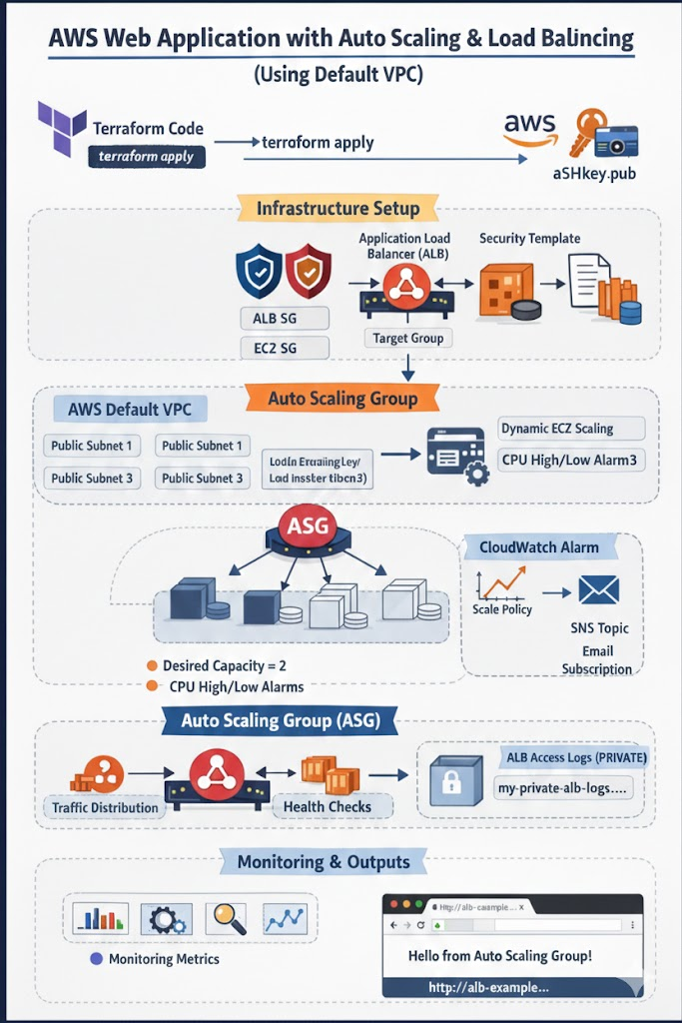

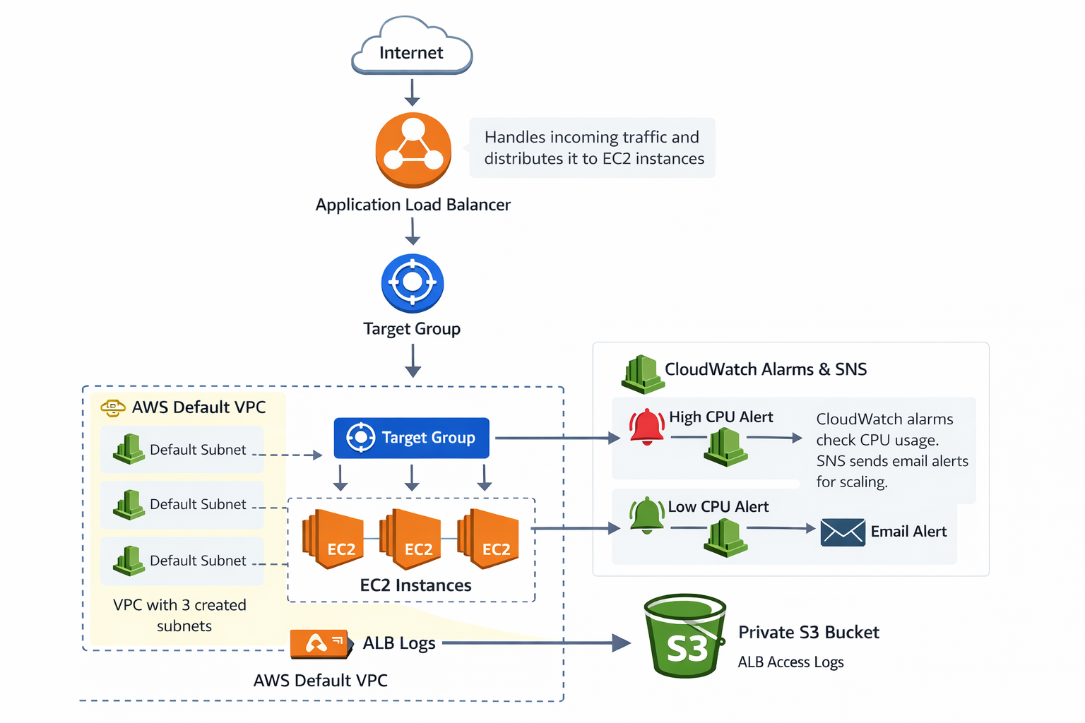

1. Project Overview & Objective
The goal of this project is to deploy a High-Availability Web Application using Terraform.
- Automation: Every resource is defined as code.
- Scalability: The system grows and shrinks based on traffic (CPU usage).
- Security: Traffic is restricted via Security Groups, and logs are stored in a private S3 bucket.

2. Phase 1: Preparation (The "Global" Layer)
First, we establish our environment settings and security credentials.
- Provider Configuration: We tell Terraform to use AWS and specify our target region (us-east-1).
- Variables & tfvars: We define parameters like instance types and scaling limits so we can change them without editing the core code.
- SSH Key Pair: We generate a local key (ssh-keygen) and use the keypair.tf to upload the public key to AWS so we can access our instances if needed.

3. Phase 2: Data Discovery (The "Existing" Layer)
Instead of hardcoding IDs, we use Data Sources in data.tf to "look up" existing AWS infrastructure:
- Default VPC & Subnets: We fetch the IDs of your account's default network setup.
- Amazon Linux AMI: We dynamically find the latest Amazon Linux 2 image ID so our build is always up-to-date.

4. Phase 3: Modular Infrastructure Build
We break the project into three distinct modules for better organization:
A. S3 Module (Storage & Logging)
- Creates a private S3 bucket.
- Bucket Policy: This is critical. We apply a policy that allows the AWS Load Balancer service account to write access logs into this bucket for auditing.
B. ALB Module (The Front Door)
- Security Groups: We create two. One for the ALB (allows port 80 from everywhere) and one for EC2 (allows port 80 only from the ALB).
- Application Load Balancer: Distributes incoming traffic across our instances.
- Target Group & Listener: Defines where traffic should go and performs "Health Checks" to ensure it doesn't send users to a broken server.
C. Auto Scaling Module (The Brains)
- Launch Template: Defines what to launch (AMI, Instance Type, and the user_data.sh script which installs Apache and the website).
- Auto Scaling Group (ASG): Defines how many to launch (Min 1, Desired 2, Max 3).
- Scaling Policies: We use Simple Scaling. If CPU > 70%, add a server; if CPU < 40%, remove one.

5. Phase 4: Monitoring & Notifications
We don't want to check the dashboard manually, so we automate the alerts:
- CloudWatch Alarms: These watch the average CPU utilization of the ASG.
- SNS Topic: When an alarm triggers, AWS sends an email notification to the administrator (you) via the Simple Notification Service.

6. Execution & Verification
- Initialize: terraform init downloads the AWS provider.
- Plan: terraform plan shows exactly what will be built.
- Apply: terraform apply builds the entire stack in minutes.
- Result: Copy the alb_dns_name from the output, paste it into a browser, and see your live website!

Key Talking Points for your Demo:
- Self-Healing: Mention that if you manually terminate an instance, the ASG will detect it and automatically launch a new one.
- Security: Highlight that the EC2 instances are protected; they don't accept traffic from the public internet, only from the Load Balancer.
- Cost-Efficiency: Explain that Scaling Down during low-traffic periods saves money.
Chat gpt notes

5-Minute Explanation of the Architecture Diagram
⏱️ Minute 1: Project Overview
“This project shows how we use Terraform to build a scalable web application on AWS using the default VPC.
The goal is to automatically handle traffic, scale EC2 instances based on CPU usage, monitor performance, and store logs securely.”
The entire infrastructure is created using:
- Terraform
- AWS Default VPC
- Load Balancing
- Auto Scaling
- Monitoring and logging

⏱️ Minute 2: Infrastructure Creation with Terraform
“On the left side of the diagram, Terraform code is used.
When we run terraform apply, Terraform automatically creates all AWS resources.”
These include:
- Application Load Balancer
- Security Groups
- Auto Scaling Group
- EC2 instances
- CloudWatch alarms
- SNS notifications
- Private S3 bucket for logs
No manual setup in the AWS console.

⏱️ Minute 3: Traffic Flow (Main Architecture)
“Traffic from the internet first reaches the Application Load Balancer.”
What happens next:
- ALB listens on port 80
- It forwards traffic to a Target Group
- The target group sends traffic to EC2 instances inside an Auto Scaling Group
All EC2 instances run in public subnets of the default VPC.
The ALB performs health checks, so traffic only goes to healthy instances.

⏱️ Minute 4: Auto Scaling, Monitoring & Alerts
“The Auto Scaling Group ensures high availability.”
Key points:
- Desired EC2 instances: 2
- Minimum: 1
- Maximum: 3
CloudWatch monitors CPU utilization:
- High CPU → Scale out
- Low CPU → Scale in
When scaling happens:
- CloudWatch triggers a policy
- SNS sends an email notification
So the user is always informed.

⏱️ Minute 5: Logging, Security & Output
“For security and monitoring, ALB access logs are stored in a private S3 bucket.”
Important details:
- Bucket is not public
- Only ALB can write logs
- Useful for auditing and troubleshooting
Finally:
- Terraform outputs the ALB DNS name
- Users can open it in a browser and access the application

Preseantation slides

🟦 Slide 1: Project Title & Overview
Speaker Notes:
“This project demonstrates how to build a scalable web application on AWS using Terraform.
We are using the AWS Default VPC, so no custom networking is created.
The infrastructure supports load balancing, auto scaling, monitoring, alerts, and secure logging.”

🟦 Slide 2: Infrastructure as Code with Terraform
Speaker Notes:
“Terraform is used to create and manage the entire infrastructure.
When we run terraform apply, Terraform automatically provisions all AWS resources.
This removes manual configuration and ensures repeatable deployments.”

🟦 Slide 3: Default VPC Setup
Speaker Notes:
“This project runs entirely inside the AWS Default VPC.
The default VPC already has public subnets across multiple availability zones.
Our load balancer and EC2 instances are launched in these public subnets.”

🟦 Slide 4: Application Load Balancer (ALB)
Speaker Notes:
“The Application Load Balancer receives traffic from the internet.
It listens on HTTP port 80 and forwards requests to a target group.
The ALB also performs health checks to ensure traffic is sent only to healthy instances.”

🟦 Slide 5: Security Groups
Speaker Notes:
“Two security groups are used.
One allows HTTP traffic to the ALB from anywhere.
The second allows EC2 instances to accept traffic only from the ALB and SSH access from my IP.”

🟦 Slide 6: Auto Scaling Group (ASG)
Speaker Notes:
“The Auto Scaling Group manages EC2 instances automatically.
Desired capacity is set to 2 instances.
Minimum is 1 and maximum is 3, ensuring availability and cost control.”

🟦 Slide 7: Auto Scaling Policies
Speaker Notes:
“Scaling is controlled using CloudWatch alarms.
When CPU usage is high, a scale-out policy adds an EC2 instance.
When CPU usage is low, a scale-in policy removes an instance.”

🟦 Slide 8: Monitoring & Notifications
Speaker Notes:
“CloudWatch monitors CPU utilization of EC2 instances.
When alarms trigger, an SNS topic sends email notifications.
This helps administrators stay informed about scaling events.”

🟦 Slide 9: ALB Access Logs (Private S3)
Speaker Notes:
“ALB access logs are stored in a private S3 bucket.
The bucket is fully private and blocks all public access.
Only the ALB service account is allowed to write logs to the bucket.”

🟦 Slide 10: Outputs & Application Access
Speaker Notes:
“Terraform outputs the DNS name of the Application Load Balancer.
Users can access the application using this DNS URL.
The application is hosted on EC2 instances behind the load balancer.”

🟦 Slide 11: Key Benefits of This Architecture
Speaker Notes:
“This architecture provides scalability, high availability, security, and automation.
It is beginner-friendly and uses AWS best practices.
Everything is managed using Terraform, making it easy to recreate and maintain.”

🟦 Slide 12: Conclusion
Speaker Notes:
“In conclusion, this project demonstrates how Terraform can be used to deploy a complete AWS web application using the default VPC, with load balancing, auto scaling, monitoring, alerts, and secure logging.”

